Meeting Minutes

**Project:**

Entrepreneurship Support

Platform

**Meeting Type:**

Meeting with the Entrepreneurial Code Crafters

**Date:**

15 November 2024

**Time:**

12h00

**Location:**

Computer Room 3 (IIE Varsity College Durban North Campus)

**Meeting Facilitator:**

Lilitha Njeje and Allison Gopal

**Minutes Taker:**

Sibusisiwe Kunene

Call to order

•

Time: 12h00

•

Facilitator/

Chairman: Lilitha Njeje, she is our database administrator and also our group leader, alongside Allison Gopal our Lead developer

Attendees and Apologies

Malibongwe Ndlovu (Project Manager was present)

Lilitha Njeje (Database Administrator was present)

Sibusisiwe Kunene (Software Architect was present)

Avarn Sewlal: (UI/UX Designer)

Hayley Chetty: (Technical Writer)

Allison Gopal: (Lead Developer)

.

Agenda

The meeting was held on the 15th of November at the IIE Varsity College Durban North Campus, Computer Room 3 alongside the Entrepreneurial Code Crafters.

The meeting was organized by our group leader, Lilitha Njeje and Allison Gopal, opened the meeting at exactly 12h00.

Detailed meeting notes

The meeting was for the group to double check the documentation and to make changes into the documentation, we also divided the final part of the coding amongst each other. We discussed dress code for the final presentation.

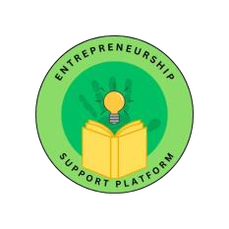

:

Adjournment

The meeting was closed at exactly 15:00.

Approval

**Minutes approved by:**

Sibusisiwe Kunene

15 November 2024 2024